# Migrating Virtual Machines to use Availability Zones

# Overview

Azure Availability Zones are one or more facilities in an Azure region that are physically and logically isolated from one another. This enables a greater isolation of resources while providing low latency and enables transparent placement and management of resources. Utilizing Availability Zones helps to protect you from datacenter-level failures. They are located inside an Azure region, and each one has its own independent power source, network, and cooling. To ensure resiliency, there's a minimum of three separate zones in all enabled regions.

Availability Zones are currently in preview. Please register your subscriptions by following the instructions at the following link:

# Scenarios

The following process and scripts support specific scenarios and should not be used as an “all inclusive” migration tool. The supported scenario requirements are as follows:

### Moving a single Virtual Machine

* Virtual machine must be using managed disk
* Must use supported Availability Zone VM size
* Understand the Public IP will change

### Additional requirements applicable to all scripts

You must ensure you are running the latest Windows PowerShell version (5.1 and above) to support the script commands.

# How To

## Single Virtual Machine Availability Zone Migration

Migration of single Virtual Machines to utilize Availability Zones can be performed if the VMs are note currently behind a load balancer or if you are utilizing software load balancers other than the Standard SKU (ex. Azure Traffic Manager, F5, etc.) and need to move only the virtual machines.

**Determine the Information on the Virtual Machines to be Moved**

To perform the migration process, you will first need to identify the following which will be used to perform the migration:

* subid - The subscription ID for the VM you want to migrate
* vmname – Name of the VM to move to the Availability Zone
* vmresourcegroup - Resource group of the VM to move to Availability Zone
* zone - Target Availability zone for the VM (1, 2 or 3)

**Use the PowerShell Migration Script to Migrate your VM’s to Zones**

Use the provided Single VM Availability Zone Migration script (MoveVMtoAZ-v7.ps1). Run the provided script using the data captured on the PowerShell command line as below:

.\MoveSingleVMtoAZ.ps1 -subid **yoursubid** -vmname **yourvmname** -vmresourcegroup **yourresourcegroup** -zone **yourtargetzone#**

**Verify the Conversion Completed Successfully**

You may verify the status of the migration in the Azure Web Portal by going to the named VM and checking the assigned Zone is correct.

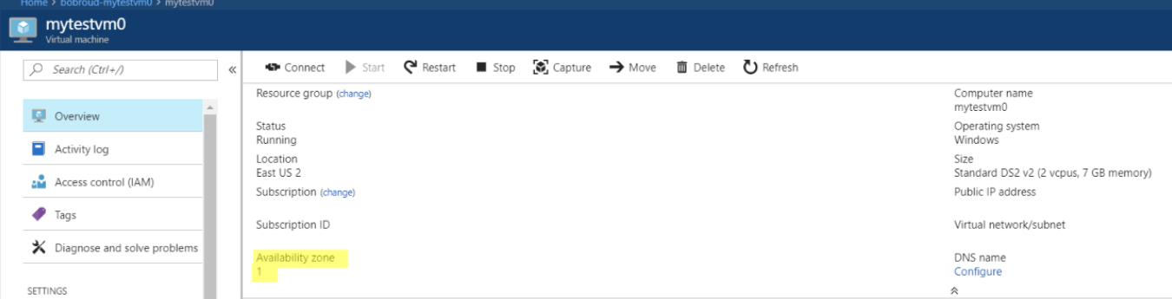

# Planning Migration Timing

The process for converting Virtual Machines to use Availability Zones takes from 3-5 minutes per VM. Since the VMs become unavailable during this time a planned maintenance window is recommended to reduce time impact. The provided scripts migrate the Virtual Machines consecutively however; you may run multiple versions of the script if you choose to run concurrently. This would reduce the overall outage window for large numbers of Virtual Machines.

# Scripts

### Single VM Availability Zone Migration script (MoveSingleVMtoAZ.ps1)

<https://github.com/RoudyBob/azmigrationscripts/blob/master/MoveVMtoAZ-v7.ps1>

### 